Name: __________________________________

The Importance of Recycling
by Lydia Lukidis
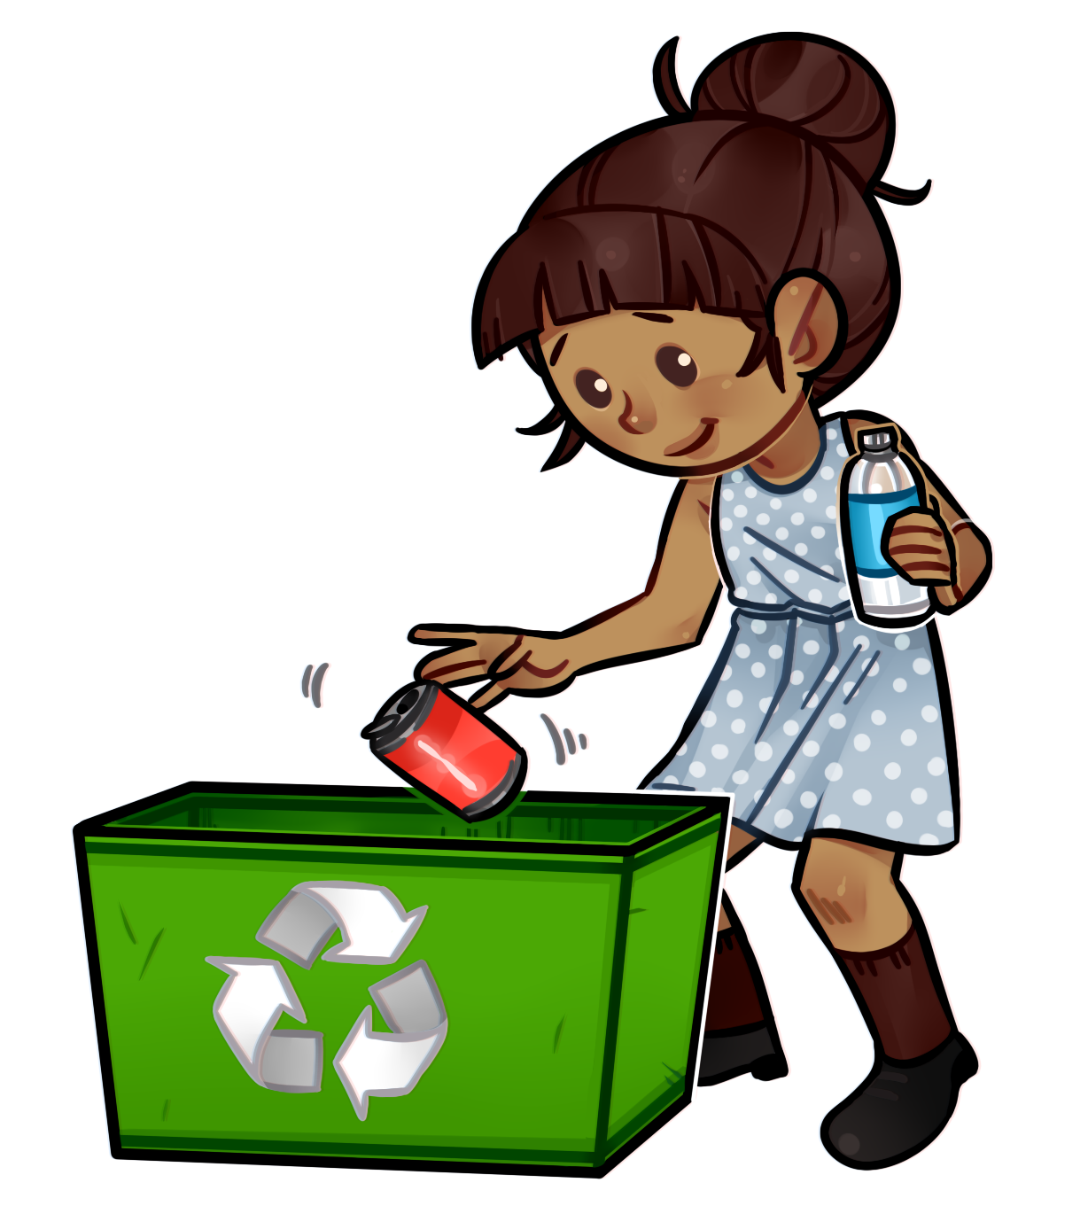
I’m sure you all know how important recycling is. Recycling is when you take old things and turn them into new things. It sounds like magic. But it’s actually very scientific.
Do you know how it all works? The first thing you have to do is collect items that can be recycled. Only certain materials can be recycled. These include things made out of paper, metal, glass and plastic. Can you think of everyday items made out of these materials? Soda cans are a good example. They are made out of metal. Magazines and newspapers are made out of paper. So are cereal boxes. Some bottles of juice are made out of glass. Bags and yogurt containers are made out of plastic. There are many things that can be recycled.
These things are usually stamped with the recycling loop. It has 3 arrows that go in a triangular circle. This shows that the cycle continues. Items are thrown away but continue their lives as something else.
Let’s get back to the process of recycling. Once you put all your items in a recycling bin, a truck comes to pick them up. Everything goes to a recycling plant. There, the materials get separated. They go into different piles. There are special machines that crush each pile together. The materials get squashed into square
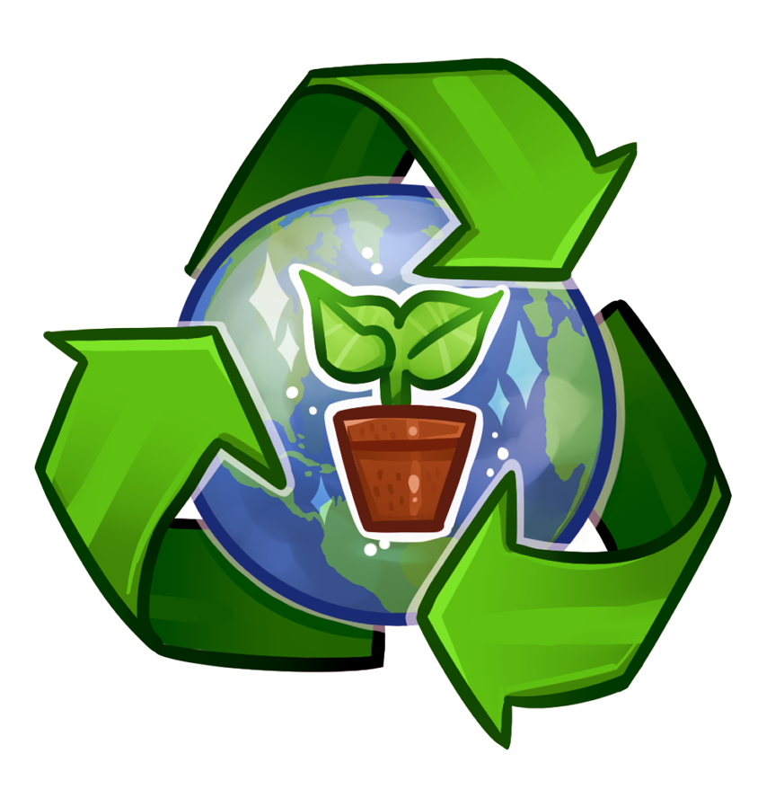
cubes. They are really heavy. You would need a forklift to carry them.
Companies buy these cubes and turn them into new products.
Now let’s take a closer look at how old paper is transformed. First the paper is torn into tiny pieces. Then a special water with chemicals is poured onto it. The fibers start to stick together. In time, a brand new roll of paper is created! If there were things written or printed on the first paper, they disappear.
Recycling keeps our planet healthy. It reduces waste. It also saves energy. You can do your part. So just remember the golden rule: always recycle your products!

About the Author

Lydia Lukidis is a published children's author with a multi- disciplinary background that spans the fields of literature, theater and puppetry.
Lydia's picture book, Gerbs in the House: The Dilly Dally Bedtime Routine, is now available. Find out if Mocha will ever get his silly son to sleep!
Lukidis, Lydia. Gerbs in the House: The Dilly Dally Bedtime Routine ISBN: 978-0-9917402-7-7
Name: __________________________________

The Importance of Recycling

by Lydia Lukidis

1. According to the article, give four examples of household items that can be recycled.

__________________________________________________________

__________________________________________________________

2. The following choices are steps in the process of recycling. Write a number (1 – 4) on the line next to each step to show which happens first, which happens next, and which happens last.

_____ Companies buy the cubes of crushed materials and turn them into new products.

_____ The items you put in your recycling bin get picked up by a truck and brought to a recycling plant.

_____ The materials get separated into different piles.

_____ Special machines crush each pile into a square cube.

3. What do the three arrows of the recycling loop show?

________________________________________________________________________________________

4. When old paper is transformed into new paper, what causes the fibers of the tiny pieces of paper to stick together?

a. a thick, sticky paste
b. a special water with chemicals poured onto it
c. a very strong glue
d. a yellow powder

5. What are two ways that recycling keeps our planet healthy?

________________________________________________________________________________________

Name: __________________________________

The Importance of Recycling

by Lydia Lukidis

Match each vocabulary word from the article with the correct definition.

_______ 1. crush a. makes smaller

_______ 2. disappear b. a box used to store things

_______ 3. scientific c. steps that happen one after another in the same order

_______ 4. bin d. to squeeze something very hard until it breaks

_______ 5. reduces e. a machine that can carry heavy loads

_______ 6. products f. to go out of view

_______ 7. cycle g. having to do with science

_______ 8. forklift h. eager to learn about something new

_______ 9. curious i. things that are made
Name: __________________________________

The Importance of Recycling

by Lydia Lukidis

In the article, “The Importance of Recycling”, you learned what recycling is, how it works, and why it's important for our planet.
Choose an item in your household that your family is able to recycle. Using the Internet, research how much of that item is recycled in the United States every year. What do you think would happen if more people recycled that one item? What do think would happen if people did not recycle that item at all?

______________________________________________________________________________________

______________________________________________________________________________________

______________________________________________________________________________________

______________________________________________________________________________________

______________________________________________________________________________________

______________________________________________________________________________________

______________________________________________________________________________________

______________________________________________________________________________________

______________________________________________________________________________________

______________________________________________________________________________________

______________________________________________________________________________________

______________________________________________________________________________________

______________________________________________________________________________________

ANSWER KEY

The Importance of Recycling

by Lydia Lukidis
1. According to the article, give four examples of household items that can be recycled .

soda cans, magazines, cereal boxes, bottles of juice

2. The following choices are steps in the process of recycling. Put a number (1 – 4) on the line next to each step to show which happens first, which happens next, and which happens last.

4 Companies buy the cubes of crushed materials and turn them into new products.

1 The items you put in your recycling bin get picked up by a truck and brought to a recycling plant.

2 The materials get separated into different piles.

3 Special machines crush each pile into a square cube.

3. What do the three arrows of the recycling loop show?

Recycling allows items to continue their lives as something else.

4. When old paper is transformed into new paper, what causes the fibers of the tiny pieces of paper to stick together? b

a. A thick, sticky paste
b. A special water with chemicals poured onto it
c. A very strong glue
d. A yellow powder

5. What are two ways that recycling keeps our planet healthy?

Recycling reduces waste. Recycling saves energy.

ANSWER KEY

The Importance of Recycling

by Lydia Lukidis

Match each vocabulary word from the article with the correct definition.

d 1. crush a. makes smaller

f 2. disappear b. a box used to store things

g 3. scientific c. steps that happen one after another in the same order

b 4. bin d. to squeeze something very hard until it breaks

a 5. reduces e. a machine that can carry heavy loads

i 6. products f. to go out of view

c 7. cycle g. having to do with science

e 8. forklift h. eager to learn about something new

h 9. curious i. things that are made

